VLSI DESIGN INTERNSHIP – TASK 3
Verilog RTL Design of Sequential Circuits and Flip-Flops
Submitted by: Shruti Vyas

1. D Flip-Flop
RTL Code
module d_ff(input clk, input reset, input d, output reg q);
always @(posedge clk) begin
if (reset) q <= 1'b0;
else q <= d;
end
endmodule
Testbench
module tb_d_ff;
reg clk, reset, d;
wire q;
d_ff uut(.clk(clk),.reset(reset),.d(d),.q(q));
initial begin
clk=0;
forever #5 clk=~clk;
end
initial begin
reset=1; d=0;
#10 reset=0;
#10 d=1;
#10 d=0;
#10 d=1;
#10 $finish;
end
endmodule
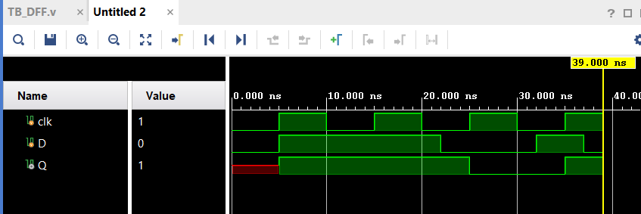
Figure 1: D Flip-Flop waveform

2. JK Flip-Flop
RTL Code
module jk_ff(input clk, input reset, input j, input k, output reg q);
always @(posedge clk) begin
if (reset) q <= 1'b0;
else case ({j,k})
2'b00: q <= q;
2'b01: q <= 1'b0;
2'b10: q <= 1'b1;
2'b11: q <= ~q;
endcase
end
endmodule
Testbench
module tb_jk_ff;
reg clk, reset, j, k;
wire q;
jk_ff uut(.clk(clk),.reset(reset),.j(j),.k(k),.q(q));
initial begin
clk=0;
forever #5 clk=~clk;
end
initial begin
reset=1; j=0; k=0;
#10 reset=0;
#10 j=1; k=0; // set
#10 j=0; k=1; // reset
#10 j=1; k=1; // toggle
#20 $finish;
end
endmodule
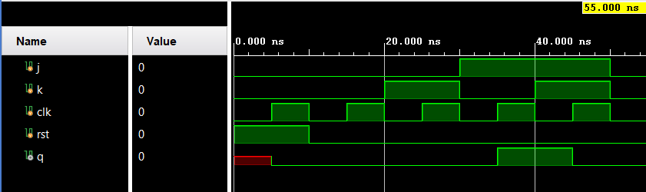
Figure 2: JK Flip-Flop waveform

3. 4-bit Register
RTL Code
module register_4bit(
input clk, input reset,
input [3:0] d, output reg [3:0] q
);
always @(posedge clk) begin
if (reset) q <= 4'b0000;
else q <= d;
end
endmodule
Testbench
module tb_register_4bit;
reg clk, reset;
reg [3:0] d;
wire [3:0] q;
register_4bit uut(.clk(clk),.reset(reset),.d(d),.q(q));
initial begin
clk=0;
forever #5 clk=~clk;
end
initial begin
reset=1; d=4'b0000;
#10 reset=0;
#10 d=4'b1010;
#10 d=4'b0101;
#10 d=4'b1111;
#10 $finish;
end
endmodule
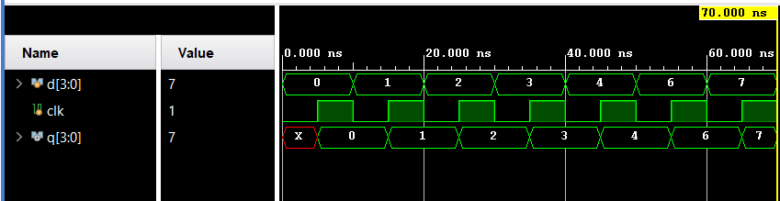
Figure 3: 4-bit Register waveform

4. 4-bit Up Counter
RTL Code
module counter_4bit(
input clk, input reset,
output reg [3:0] count
);
always @(posedge clk) begin
if (reset) count <= 4'b0000;
else count <= count + 1'b1;
end
endmodule
Testbench
module tb_counter_4bit;
reg clk, reset;
wire [3:0] count;
counter_4bit uut(.clk(clk),.reset(reset),.count(count));
initial begin
clk=0;
forever #5 clk=~clk;
end
initial begin
reset=1;
#10 reset=0;
#80 $finish;
end
endmodule
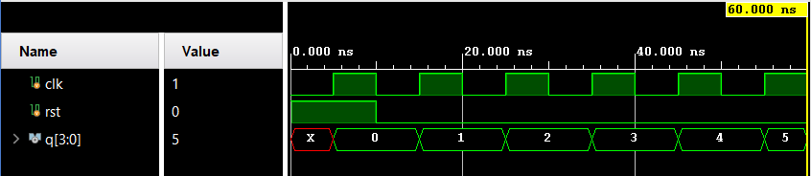
Figure 4: 4-bit Up Counter waveform

5. Result
The Verilog RTL modules and their testbenches were prepared for the required sequential circuits. The waveforms show the expected clock-driven behavior of the flip-flops, register, and counter.

6. Conclusion
The task was completed by implementing sequential circuits in Verilog HDL, creating testbenches, and verifying their operation through simulation waveforms.

